Zoot Suit by Luis Valdez

Anticipatory Guide
Agree/Disagree
- Although the production of Zoot Suit shattered all box office records when it played in Los Angeles, a Chicano play would never make it to Broadway.
- The Sleepy Lagoon Murder Trial was symbolic of the racial intolerance against Mexicans in Los Angeles.
- Mexican American youth who assimilated into American culture received the same privileges and treatment as other American youth.
- There was plenty of adequate housing for immigrants during the early 1900’s.
- Gangs have existed in the United States since as far back as the nineteenth century.
- Highly prompted by the fashion industry, the Zoot Suit influenced attire became the fashion craze for young men and women, during the 30′s and 40′s.
- After serving valiantly for the United States in World War II, service men and women of Mexican ancestry were still denied equal access and equal rights.
- Partner dancing was a popular form of social recreation for young people in the 1940s.
- Artists of color popularized many new types of music, such as bebop, rhythm and blues, and big band swing.
- Luis Valdez was one of the first Chicano composers to write music about the Chicano movement and Chicano life.
- Pachuco and Pachuca youth should have used Standard English and not Caló, their language style, to avoid problems with the law.
- Defendants have the right to wear clean clothes, bathe and cut their hair for their court appearance.
- Known gang members should be detained and placed in jail on suspicion of wrongdoing until the case is solved for the protection of all citizens.
- Final verdicts in the courtroom can be overturned with insufficient evidence, the denial of the defendant’s right to counsel and overt bias on the part of the judge.
- The sensationalist misrepresentation of youth and gangs is a form of “yellow journalism” that still occurs today.
Prediction Activity: Look at the images below and respond to each prompt.
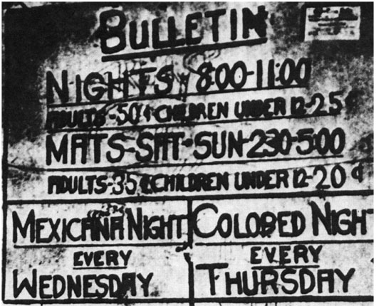

Image #1: Predict what you think this billboard represents? Explain your response.

Image #2: Who are these people? What do you predict is happening in this picture?

Image #3: Who are these people? What do you predict is happening in this picture?

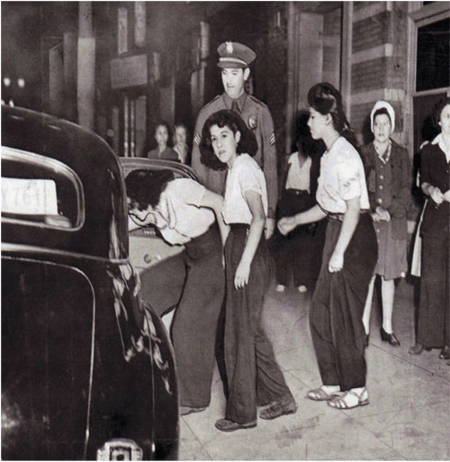

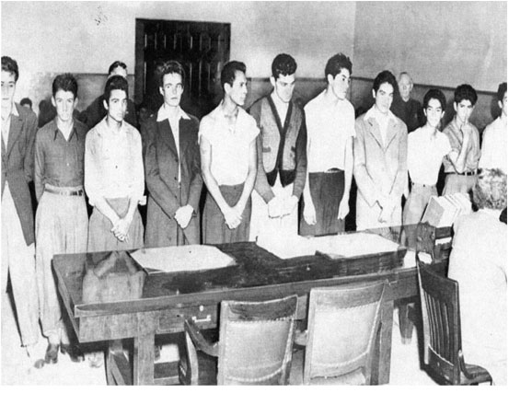

Language Connection: Group Activity
Each student will conduct a brief analysis/investigation of a term or name that is important to the understanding of the text.
- Caló
- Chicano/Chicana
- Pachuco/Pachuca
- Sleepy Lagoon Murder Trial
- Zoot Suit
- Zoot Suit Riots
- Corridos
- Latino/Latina
- El Teatro Campesino
- American G.I. Forum
- G.I. Bill
- Cab Calloway
- Lalo Guerrero
- German Valdés or Tin Tan
- Boleros
- Jitterbug
- Big Band
- Grand Banda de Swing
- Pareja de baile
- Jingoism
- Nativism
- Racial profiling
- Sleepy Lagoon Defense Committee
- Xenophobia
- Yellow journalism
Students will complete a poster that includes the following:
- Definition according to two different sources
- Five important facts
- Examples, graphics or pictures
Reflection Logs
First Entry Teatro: Political Theatre Chicano Style
“The Acto:” Complete the following exercises in groups of 4-5 students.
- Imagine you are a playwright, what current or past events would inspire you to write an acto (short scene) addressing social injustice?
- It can be current or past events like the:
  - April 29, 1992 City of Los Angeles “Rodney King” Riots
  - May 1, 2006 The Great American Boycott addressing Immigration Rights
  - January 1, 2009 New Year’s Day shooting death of Oscar Grant by a Bay Area Rapid Transit (BART) Officer
- Investigate the event and with your group write an acto with at least two characters and a narrator.
- Self-edit, peer edit and lastly have the teacher edit your draft.
- Chose actors for your scene and perform it for the class.
- Discuss the performance.
Second Entry Immigration Waves
“My Family:” Complete the following exercise on your own.
- Trace the migration of your family to the United States in a pictorial essay. Choose the journey of one family member or an entire family. Include the following:
  - Description of place of origin
  - Reasons for leaving the country
  - Reasons for migrating to the United States
  - The migration journey
  - Difficulties confronted
  - Support received
  - Final destination
- Self-edit, peer edit and lastly share your story with the class.
Third Entry ¡Pachuco y Pachuca Yo!
“Style Warfare:” The Wartime Productions Board in 1942 attempted to cut back on fabric which directly targeted Zoot Suiters.
- Complete the following exercises.
  - Describe your thoughts of what you think it would be like to wear a Zoot Suit as a young Pachuco or Pachuca in the 1940s.
  - How did women defy traditional roles and expectations by wearing Zoot Suits?
  - Describe how clothes today define your style and who you are.
- Think of a piece of clothing that is very popular for your age group. Write a newspaper article. Begin with the title, “Ban on _____________ Studied by City Council.” (i.e. Ban on Baggy Low Jeans Studied by City Council) Write a full page.
The Power of the Press

Read the newspaper articles from the Zoot Suit Riots at this website to learn how the media using yellow journalism misrepresented Pachuco youth and caused negative repercussions. Read the articles with the members of your group. Focus on the headlines, events, criminals, victims and police response as you read each one. What do these articles have in common?
Describe the events that have been sensationalized by the media. Use the graphic organizer to guide your thoughts.
 | Artículos de periódico | Perspectivas diferent
Encabezados
Eventos
Criminales
Victimas
Respuestas de la Policía
Respuestas de la publico

Read about the Zoot Suit Riots from “A Different Perspective”. Fill out the graphic organizer and describe each area, emphasizing a different perspective.

MUSIC AND DANCE OF THE ZOOT SUIT ERA
During WWII, music and dance led the way to a cultural renaissance on the streets of Los Angeles. By listening to the following songs that were featured in Zoot Suit, Los Chucos Suaves and Vamos a Bailar, students will have the opportunity to learn more about Eduardo “Lalo” Guerrero, the father of Chicano music and, the popular partner dancing to big band swing.
- Listen to Los Chucos Suaves. (The lyrics are in Spanish. For an English translation click here)
  - List the attributes of the Chicano big band swing.
  - What message do the lyrics communicate?
  - What is the style of the music?
  - What instruments do you hear?
  - What’s your overall impression?
  - How did Lalo Guerrero influence big band swing?
- Watch the Saturday Night Dance performed by Round Rock Ballet Folklorico.
  - Describe the attributes of the dance style?
  - What message does the dance communicate?
  - How does the attire worn by the dancers influence the style?
  - What’s your overall impression?
  - How did both Cab Calloway and Germán Valdés influence partner style dancing?
- After listening to the song and watching the movie fill in the following matrix. Once the matrix is filled, choose one area, music or dance, and develop a poster that highlights all of your information.

Grand Banda de Swing | Pareja de baile
“Eduardo Laslo” Guerrero | Cab Calloway & Germán Vladés  (aka Tin Tan)

Los Chucos Suaves (Music and lyrics by Lalo Guerrero)
Antes se bailaba swing, They used to dance the swing,
Boogie-woogie, jitterbug. Boogie-woogie, jitterbug.
Pero esto ya torció. But that has all changed,
Y este es lo que sucedió. And this is what is happening today.

Pachucos suaves bailan rumba, Cool Chucos dance the rumba,
Bailan la rumba y le zumba. Dance the rumba and the zumba.
Bailan guaracha sabrosón, Dance the tasty guaracha,
El botecito y el danzón. The botecito and the danzon.

Cada sábado en la noche Each Saturday night,
Yo me voy a borlotiár I go to dance,
Con mi linda pachucóna. To stir my hips
Las caderas a menear. With my pretty pachucona.

Ella le hace muy aquellas She takes on airs,
Cuando empieza a guarachar. When she begins to guarachar
Al compas de los timbales, To the beat of the timbales.
Yo me siento petetear. I want to die right there.

Directed Reading with Number Heads
Zoot Suit Main Characters
1. Who are the main characters of Zoot Suit? Describe their role in the play and importance to the murder trial.
Luis Valdez, The Playwright
2. What are some of the important accomplishments and achievements of Luis Valdez? Explain why are these significant.
Teatro – Political Theatre Chicano Style
3. Define “teatro.”
4. What are some of the distinctive characteristics of teatro? Why are these important?
5. What are the elements that classify Zoot Suit as a prime example of Teatro Chicano?
From Mexico to the United States
6. Why was there a mass migration to the United States between 1910 and 1914?
7. What fueled the second mass migration to the United States?
8. Why wasn’t adequate housing an option for Mexican residents? Explain.
9. What difficulties did Mexican American youth confront? Explain.
10. What do you learn about the Bracero Program and Chávez Ravine?
11. How would you define acculturate and assimilate? Give examples of each.
12. How and why did gangs emerge on the streets?
Mexican Americans in World War II
13. How did Latinos/as contribute to the war effort? Give specific examples.
14. What was the highest rank and honor received by a military veteran of Mexican descent? Why is this significant?
15. After serving valiantly for the United States, how were service men and women of Mexican descent welcomed home?
16. Why was the American G. I. Forum established? Why was this important?
17. What benefits did these service men and women receive?
18. What are some facts that you learn about Latinos serving in the military during World War II?
L.A. In The Zoot Suit Era
19. How did music contribute to a cultural renaissance on the streets of Los Angeles?
20. Who were some of the key people who contributed to this cultural renaissance in music and songwriting? What was their contribution?
21. Why is Lalo Guerrero considered to be one of the most influential and important Chicano musicians of the twentieth century? Explain.
22. How did partner dancing evolve over time?
¡Pachuco y Pachuca Yo!
23. Where did the term Pachuco come from?
24. Describe the Pachuco’s style of dress? What was the Bonaroo look?
25. Describe the Pachuca’s style of dress?
26. Why were Pachucos considered unpatriotic?

